EBook4U

Use-Case Specification

Version <1.1>

Revision History

|  |  |  |  |
| --- | --- | --- | --- |
| **Date** | **Version** | **Description** | **Author** |
| 15/11/2022 | 1.1 | Write Use-case SpecsFile | Tran Van That |
|  |  |  |  |
|  |  |  |  |
|  |  |  |  |

Table of Contents

1. Use-case Model 4

2. Use-case Specifications 5

2.1 Use-case: Login 5

2.2 Use-case: Register 6

2.3 Use-case: Forget password 6

2.4 Use-case: Manage book 6

2.5 Use-case: Manage report 7

2.6 Use-case: Manager user account 7

2.7 Use-case: Manage profile 7

2.8 Use-case: Rating and report 8

2.9 Use-case: Manage favorite books 8

2.10 Use-case: Manage history viewed book 8

2.11 Use-case: Search 9

# Use-case Model

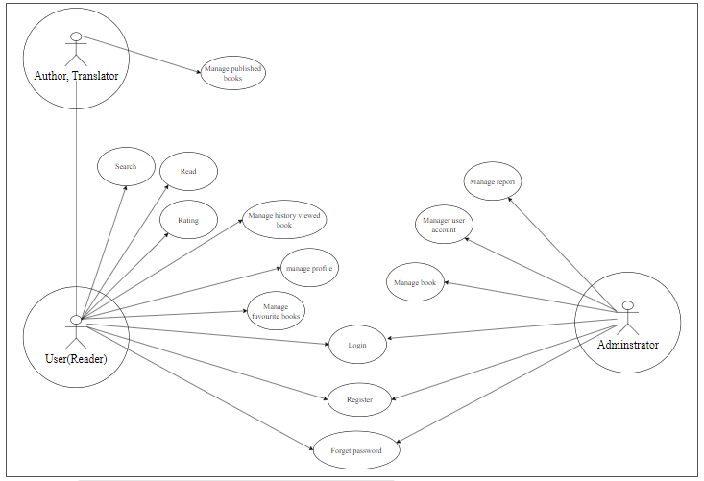

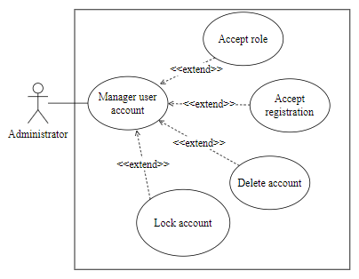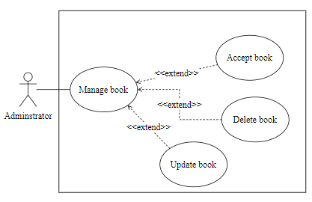

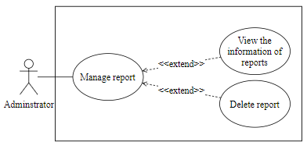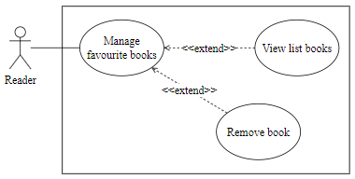

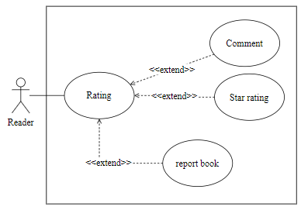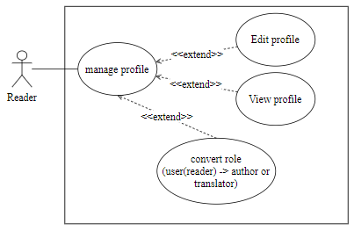

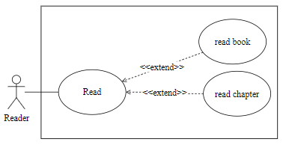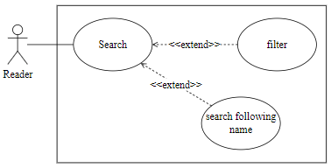

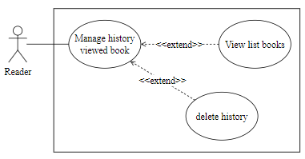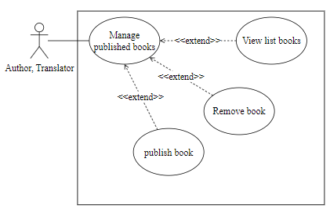

# Use-case Specifications

## Use-case: Login

|  |  |
| --- | --- |
| Use case Name | Login |
| Brief description | User and admin login into website |
| Actors | Reader, Admin |
| Basic Flow | 1. At the homepage, click on “Đăng nhập” button 2. Fill out username and password 3. Click OK |
| Alternative Flows | **Alternative flow 1: Username or password is incorrect**   1. Refill username or password |
| Pre-conditions | User goes to the homepage at [EBook4U](http://www.ebook4u.com.vn), clicks on the “Đăng nhập” button. |
| Post-conditions | User successfully login to website |

## Use-case: Register

|  |  |
| --- | --- |
| Use case Name | Register |
| Brief description | User register account to access website |
| Actors | Reader |
| Basic Flow | 1. At the homepage, click on “Đăng ký” button 2. Enter username, password, re-enter password 3. Click OK |
| Alternative Flows | **Alternative flow 1: Username already exists**   1. Refill username   **Alternative flow 2: Re-enter password incorrect**   1. Refill password |
| Pre-conditions | User goes to the homepage at [EBook4U](http://www.ebook4u.com.vn), clicks on the “Đăng ký” button. |
| Post-conditions | User successfully register an account. |

## Use-case: Forget password

|  |  |
| --- | --- |
| Use case Name | Forget password |
| Brief description | Reader forgets password and asks for a new password |
| Actors | Reader |
| Basic Flow | 1. Click on “Quên mật khẩu” 2. Fill out username or email. 3. The system sends the password back to the user by email. 4. User logins again with that password. |
| Alternative Flows | **Alternative flow 1: Account do not have email**   1. Register new account   **Alternative flow 2: Email is incorrect**   1. Refill email or register new account |
| Pre-conditions | User goes to the homepage at [EBook4U](http://www.ebook4u.com.vn), clicks on the “Quên mật khẩu” |
| Post-conditions | User has new password to login to website |

## Use-case: Manage book

|  |  |
| --- | --- |
| Use case Name | Manage book |
| Brief description | Admin makes a change on the list book. |
| Actors | Admin |
| Basic Flow | 1. Click on the “Xóa” button beside the book in the list . 2. Click on the “Cập nhật” beside the book in the list . 3. Click on the “Tạo mới” button in the list . |
| Alternative Flows | **Alternative flow 1: Create or update wrong type file**   1. Re Update. |
| Pre-conditions | Login with admin account to take this action |
| Post-conditions | Update data successfully |

## Use-case: Manage report

|  |  |
| --- | --- |
| Use case Name | Manage report |
| Brief description | Take action upon receipt of report |
| Actors | Admin |
| Basic Flow | 1. See the report in the list  2 .Delete comments  3. Ban user comment 1 month |
| Alternative Flows | **Alternative flow 1: Fake report**   1. Check then ignore report   **Alternative flow 2: Comment was deleted before being checked**   1. Ignore report |
| Pre-conditions | Login with admin account to take this action |
| Post-conditions | Censorship successful |

## Use-case: Manager user account

|  |  |
| --- | --- |
| Use case Name | Manager user account |
| Brief description | Perform user account management such as adding, editing, deleting,.. |
| Actors | Admin |
| Basic Flow | 1. Click on the “Quản lý” button 2. Click on “Thêm”,”Sửa” ,”Xóa”,”Tìm kiếm” in the management account interface |
| Alternative Flows | **Alternative flow 1: Account not found**   1. Maybe the account doesn't exist or entered wrong |
| Pre-conditions | Login with admin account to take this action |
| Post-conditions | Successful implementation |

## Use-case: Manage profile

|  |  |
| --- | --- |
| Use case Name | Manage profile |
| Brief description | The user can view your information and you can edit and convert your role if you want to become an author or translator for a website. |
| Actors | Reader |
| Basic Flow | 1. Hover avatar on any page of website and click the button “Trang cá nhân” or click your avatar |
| Alternative Flows | **Alternative flow 1: Edit your profile**   1. Confirm password before saving   **Alternative flow 2: Convert role**   1. Wait admin to confirm |
| Pre-conditions | User must login to take this action |
| Post-conditions | User can complete your profile and become author or translator to contribute to this website |

## Use-case: Rating and report

|  |  |
| --- | --- |
| Use case Name | Rating |
| Brief description | Reader reviews books by giving from 1 to 5 star in star rating button or comments or report to admin if this book has inappropriate content. |
| Actors | Reader |
| Basic Flow | 1. Click button “Đánh giá” or button “Báo cáo” 2. If you click button “Đánh giá”, you can write your opinion 3. If you click the button “Báo cáo”, you can write the reason and tick some of the content violations. |
| Alternative Flows | **Alternative flow 1: Comment has toxic, spam comments**   1. Reader reports to send this comment to admin 2. Admin checks and bans that comment for 1 month.   **Alternative flow 2: Report is correct**   1. Send notification to the author or translator 2. Admin check and delete reported book |
| Pre-conditions | User must login to take this action |
| Post-conditions | Users comment or report a book successfully  Admin check and ban users or delete book completely |

## Use-case: Manage favorite books

|  |  |
| --- | --- |
| Use case Name | Manage favorite books |
| Brief description | The reader can view books which are ticked as their favorite. |
| Actors | Reader |
| Basic Flow | 1. Click on the button that has a heart icon in the detail book page one time. 2. If you want to remove this book from your list of favorite books you can tick one more time or click the button “x” in your favorite books page. |
| Alternative Flows |  |
| Pre-conditions | User must login to take this action |
| Post-conditions | User can add or remove book from their list of favorite books |

## Use-case: Manage history viewed book

|  |  |
| --- | --- |
| Use case Name | Manage history viewed book |
| Brief description | The reader can see books which are viewed by you |
| Actors | Reader, Guest |
| Basic Flow | 1. Every time you view any book on the website, which adds to this list automatically. 2. If you want to remove any book in this list you can click the button “x” in your history books page or if you want to clear this list, you can click the button “Xóa tất cả” on your history books. |
| Alternative Flows |  |
| Pre-conditions | No conditions |
| Post-conditions | User can remove or clear list history viewed book |

## Use-case: Search

|  |  |
| --- | --- |
| Use case Name | Search book |
| Brief description | The reader can search for any book to know it exists on the website or filter to see books having the same category or author … |
| Actors | Reader, Guest |
| Basic Flow | 1. Click the box input search in the header of the website 2. Type the name of the book you need to find 3. If you want to filter a list book with some condition you can click the button filter near the box search |
| Alternative Flows | **Alternative flow 1: search not found**   1. Redirect to page not found |
| Pre-conditions | Type something to box search or tick something. |
| Post-conditions | Users can find the books they need to read and filter a list book with some conditions they need. |